Lift
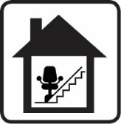 Stairlift
Mobility Scooter Store
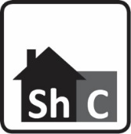 Sheltered Housing - Communal
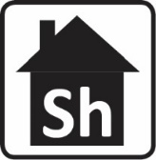 Sheltered Housing
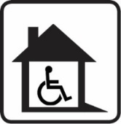 Suitable for people with mobility needs
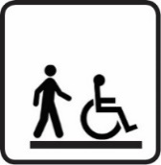 Level/easy access
Through Floor lift

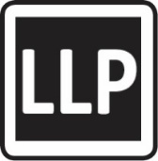 Local Lettings Policy – These homes are let to specific customer groups based on their housing needs. The groups have been chosen due to the specific nature of the area and/or property types.

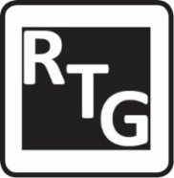 Resident and Tenants’ Group - This symbol means that these homes are represented by a Registered Tenant Group (RTG). A representative may attend viewings with the successful customer.

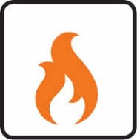 Total Heat - Heat Lease charge – A property subject to a Heat Lease charge as a new central heating system has recently been installed. You will be charged an additional amount to the weekly rent as follows: 1 or 2 bed - £3.23; 3 bed - £3.46; 4 bed or more - £4.06.

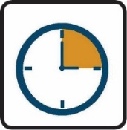 Date of Registration Quota - Date of Registration: homes advertised with this symbol will be let to the bidder with the earliest date of registration and a local connection to the ward area. Maps of ward areas can be found here. Successful bidders will need to provide proof of a local connection within 3 days of being made an offer.
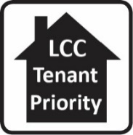 Tenant Transfer Property - The tenant transfer quota is where we advertise 10% of council homes giving preference to our tenants who have a good tenancy record and a local connection to the Ward area ahead of other applicants.
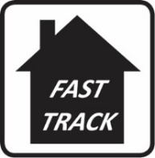 Fast Track Properties - Council properties that are not let on the first advertisement may be re-advertised as ‘Fast track’ properties. Fast track property adverts may be added to the Leeds Homes website on any day of the week including Tuesdays, and will normally be advertised for at least one day. Fast track properties will only be available on the website, not the flyer. Offers of Fast track properties will normally be made to the customer in the highest housing need who meet the lettings criteria.

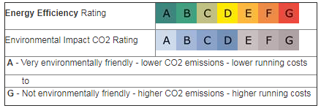

S

